CSE520
Samuel Marrujo
Professor Yu
Lab 02

Draw a square with Android

In this lab, we are to take triangles and create a yellow square using the Android libraries and using the Eclipse IDE. I have successfully completed this task, and here is a picture of the following:
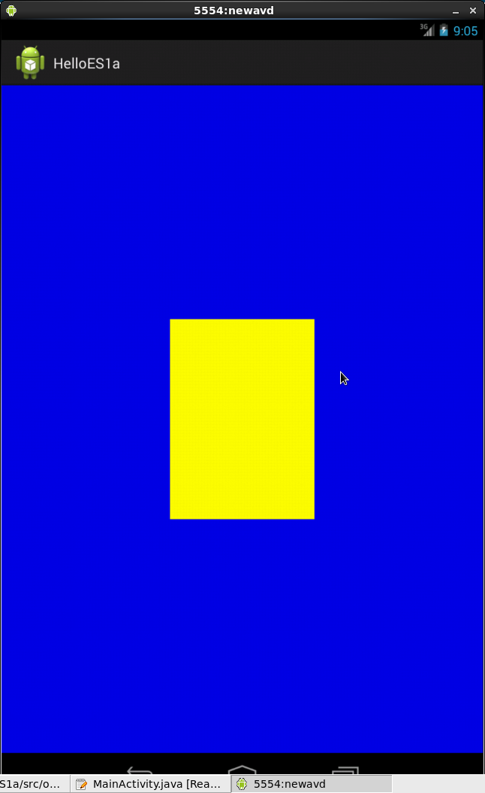
Main Activity Code:

package opengl.helloes1a;
import android.app.Activity;
import android.os.Bundle;
import android.content.Context;
import android.opengl.GLSurfaceView;
public class MainActivity extends Activity {
private GLSurfaceView mGLView;
@Override
public void onCreate(Bundle savedInstanceState) {
super.onCreate(savedInstanceState);
// Create a GLSurfaceView instance and set it
// as the ContentView for this Activity.
mGLView = new HelloESSurfaceView(this);
setContentView(mGLView);
}
@Override
protected void onPause() {
super.onPause();
// The following call pauses the rendering thread.
mGLView.onPause();
}
@Override
protected void onResume() {
super.onResume();
// The following call resumes a paused rendering thread.
mGLView.onResume();
}
class HelloESSurfaceView extends GLSurfaceView {
public HelloESSurfaceView(Context context){
super(context);
// Set the Renderer for drawing on the GLSurfaceView
setRenderer(new HelloESRenderer());
}
}
}

Renderer Code:

package opengl.helloes1a;
import android.os.Bundle;
import android.app.Activity;
import android.view.Menu;
import java.nio.ByteBuffer;
import java.nio.ByteOrder;
import java.nio.FloatBuffer;
import javax.microedition.khronos.egl.EGLConfig;
import javax.microedition.khronos.opengles.GL10;
import android.opengl.GLSurfaceView;

public class HelloESRenderer implements GLSurfaceView.Renderer {

private FloatBuffer triangle;
private FloatBuffer triangle2;
public void onSurfaceCreated(GL10 gl, EGLConfig config) {
// Set the background frame color to blue
gl.glClearColor(0.0f, 0.0f, 0.9f, 1.0f);
// initialize the triangle vertex array
initShapes();
initShapes2();
// Enable use of vertex arrays
gl.glEnableClientState(GL10.GL_VERTEX_ARRAY);
}
public void onDrawFrame(GL10 gl) {
// Redraw background color
gl.glClear(GL10.GL_COLOR_BUFFER_BIT | GL10.GL_DEPTH_BUFFER_BIT);
// Draw the triangle using green color
gl.glColor4f(1.0f, 1.0f, 0.0f, 0.0f);
gl.glVertexPointer(3, GL10.GL_FLOAT, 0, triangle);
gl.glDrawArrays(GL10.GL_TRIANGLES, 0, 3);
gl.glVertexPointer(3, GL10.GL_FLOAT, 0, triangle2);
gl.glDrawArrays(GL10.GL_TRIANGLES, 0, 3);
}
public void onSurfaceChanged(GL10 gl, int width, int height) {
gl.glViewport(0, 0, width, height);
}
private void initShapes(){
float vertices[] = {
// (x, y, z) of triangle
-0.3f, -0.3f, 0,
0.3f, 0.3f, 0,
-0.3f, 0.3f, 0
};

// initialize vertex Buffer for triangle
// argument=(# of coordinate values * 4 bytes per float)
ByteBuffer vbb = ByteBuffer.allocateDirect(vertices.length*4);
// use the device hardware’s native byte order
vbb.order(ByteOrder.nativeOrder());
// create a floating point buffer from the ByteBuffer
triangle = vbb.asFloatBuffer();
// add the coordinates to the FloatBuffer
triangle.put(vertices);
// set the buffer to read the first vertex coordinates
triangle.position(0);
}
private void initShapes2(){
float vertices[] = {
// (x, y, z) of triangle 2
-0.3f, -0.3f, 0,
0.3f, -0.3f, 0,
0.3f, 0.3f, 0
};
// initialize vertex Buffer for triangle
// argument=(# of coordinate values * 4 bytes per float)
ByteBuffer vbb = ByteBuffer.allocateDirect(vertices.length*4);
// use the device hardware’s native byte order
vbb.order(ByteOrder.nativeOrder());
// create a floating point buffer from the ByteBuffer
triangle2 = vbb.asFloatBuffer();
// add the coordinates to the FloatBuffer
triangle2.put(vertices);
// set the buffer to read the first vertex coordinates
triangle2.position(0);
}
}

